Space Explorer Agent
DEFINE:-
1.Goal:
Fetch NASA’s Astronomy Picture of the Day (APOD) using NASA Open APIs, extract its description, and explain the scientific concept behind the image in simple, student-friendly language so that even kids can understand space concepts easily.
2.Input:
The system accepts natural language queries from the user, such as:
- “Show today’s space picture”
- “Explain today’s APOD”
- “Show Mars rover photos by date”
- “Give space facts about planets or black holes”
These queries help the agent decide which NASA data to fetch and what information to explain.
3.Ouput:
The system returns:
- NASA space image or image link
- Kid friendly-English explanation of the science behind the image
- Fun and interesting space facts related to the topic
This helps students learn astronomy in an easy and engaging way.
4.Constraints:
The system must follow these limitations:
- Use only free NASA Open APIs
- All explanations must be kid-friendly and easy to understand
- The system cannot control real telescopes or satellites
- It only retrieves and explains available NASA data
PROBLEM STATEMENT:
Space science is very interesting, but many students find it difficult to understand because the information is complex and technical. Most websites provide space images and scientific data, but they do not explain the science behind them in a simple and easy way for students.
Students also do not know where to find daily space pictures, Mars rover photos, and fun space facts from trusted sources.
To solve this problem, the Space Explorer Agent is developed. This system collects real space data from **NASA APIs and explains it in simple and kid-friendly language. It helps students explore space pictures, learn scientific concepts, and understand them easily.
This system makes learning about space simple, interactive, and enjoyable.it should be in kids’ friendly manner

DESIGN:

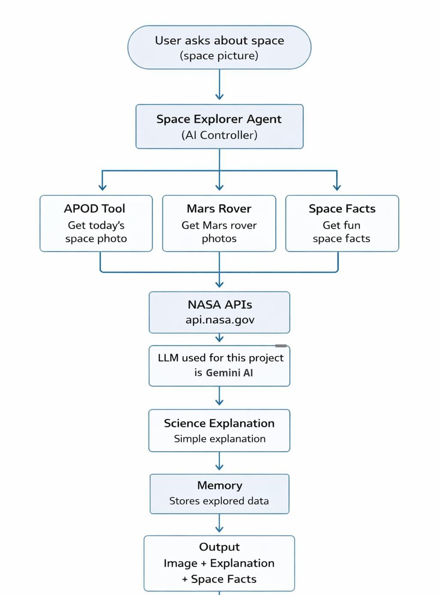

DESCRIPTION:
- The user asks a question about space, such as requesting today’s space picture or information about space.
- The Space Explorer Agent (AI Controller) receives the user’s query and understands the request.
- The agent decides which tool or function should be used to answer the query.
- The APOD Tool is used to fetch the Astronomy Picture of the Day from NASA.
- The Mars Rover Tool is used to retrieve images taken by Mars rovers on Mars.
- The Space Facts Tool provides interesting and educational space facts to the user.
- These tools connect to NASA APIs (api.nasa.gov) to collect real space data.
- The retrieved data is then sent to the Gemini API which converts complex scientific information into kids friendly explanations.
- The system also uses a Memory component to store previously explored space topics during the session.
- Finally, the output is generated, which includes the space image, simple explanation, and additional space facts for the user.

